Evaluating Bidirectional Label-Flipping and a Hybrid KNN-OOF Defense for ML-Based Network Intrusion Detection

Abstract— This document gives formatting instructions for authors preparing papers for publication in the Proceedings of an IEEE conference. The authors must follow the instructions given in the document for the papers to be published. You can use this document as both an instruction set and as a template into which you can type your own text.

Keywords— Network Intrusion Detection Systems (NIDS), Adversarial Machine Learning, Data Poisoning, Label-Flipping Attack, UNSW-NB15, KNN, Out-of-Fold Prediction
- Introduction
- Problem Statement
Nowadays, many networks are subject to cyberattacks in which attackers gain access and interfere with the network maliciously. Network intrusion is a well-known cybersecurity threat, and with ongoing technological advances, many machine-learning-based models have been increasingly used and extensively trained to distinguish between normal and malicious traffic. However, the performance of such models depends heavily on the quality of the data they are trained on, making them vulnerable to data poisoning and cyberattacks. One such attack is label flipping, in which an attacker manipulates the training data by switching the labels of some samples, such as labeling attack traffic as benign or benign traffic as attack. This can cause the model to learn incorrect classifications and patterns, affecting its performance by reducing its ability to identify malicious traffic accurately.
- Motivation
These reduced detection capabilities can have serious consequences for individuals and organizations, as network intrusion attacks may go undetected. Through these attacks, an attacker can gain unauthorized access to the system, steal sensitive information, disrupt services, and cause data breaches. Because of this, ML-based Network Intrusion Detectors need to be accurate and reliable so that organizations and individuals can use them efficiently without letting malicious intrusion attempts bypass detection. Therefore, analyzing the impact of label-flipping attacks on ML-based NIDS is crucial for understanding how vulnerable they are to these threats and how their performance and capabilities can be affected. This can further help us identify ways to make them more resistant to such attacks, improving robustness and reliability.
- Methodology
The proposed methodology consists of dataset preparation, baseline model training, simulation of label-flipping attacks, defense implementation, and performance evaluation.
- Proposed Approach
First, we will prepare our dataset, the UNSW-NB15 dataset, which consists of benign traffic and nine types of network intrusion attacks (e.g., DoS, Exploits, Reconnaissance). The classification task will use the existing binary label provided in the dataset, where 0 represents (Benign) traffic, and 1 represents (Attack) traffic. We will also clean the dataset by removing missing or null values. We will then divide the dataset into training, validation, and test sets, following a 70%, 15%, and 15% split.
Next, we will train the ML models, specifically Random Forest and Decision Tree, on the clean training set and showcase the baseline NIDS performance before the attacks by testing them on the test set. Their performance will then be evaluated using key metrics such as accuracy, precision, recall, F1-score, and the confusion matrix.
After that, we will poison the training set using a bidirectional label-flipping attack by changing the selected labels from attack (1) to benign (0), and vice versa, at poisoning rates of 10%, 20%, and 30% of the overall training set. The models will then be retrained on the poisoned set and evaluated on the clean test set. This will provide us with the opportunity to compare the performance of the system before and after the attacks and assess its vulnerability.
Next, we will apply a defense mechanism to help the system identify which instances may have flipped labels. For this, we will propose a hybrid approach combining KNN neighborhood label disagreement and out-of-fold model-label disagreement. If both defense mechanisms agree that the sample belongs to the opposite class, then it will be relabeled accordingly. For example, a suspicious benign sample might be relabeled as an attack, and a suspicious attack sample might be relabeled as benign. Otherwise, if the two mechanisms disagree or generate a low confidence score, the sample will instead be removed from the training set. The models will then be trained again on the cleaned set.
A final evaluation will then be conducted by measuring the accuracy, precision, recall, F1-score, false-positive rate, false-negative rate, and clean-data retention, as well as how accurately poisoned samples were detected. Finally, we will extensively analyze where the defense works and where it fails, its computational cost, and its limitations. A further comparison will be made with recent papers to compare the performance of the different approaches.

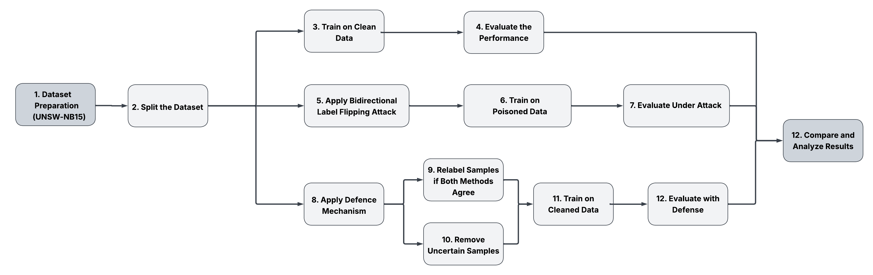
Fig. 1 Flowchart of the proposed methodology

- Tools/Dataset/Technologies
Several tools and libraries will be used in our project to support preprocessing, coding, implementation, experimentation, and evaluation. One of the main tools is Google Colab, where we will primarily code in Python. This platform is helpful because it’s simple and convenient for implementing ML-based NIDS. Other tools include NumPy and Pandas, which are Python libraries that help perform mathematical operations and handle and clean the dataset. Scikit-learn, a machine-learning library, will also be used to train ML classifiers such as Random Forest and Decision Tree, and to calculate evaluation metrics. Additionally, Matplotlib will be used to create visualizations, such as graphs and charts, when needed. To support effective collaboration, GitHub will be used to store the project online, enabling us to edit the code and documentation and track members’ contributions.
UNSW-NB15, a benchmark dataset containing network traffic classified as benign and nine categories of malicious traffic, will be the core dataset for system training and testing. The dataset is particularly useful for NIDS and contains a large number of network traffic samples, including their features and labels classifying them as either benign traffic or different types of attacks.
As for the technologies our project will use, we will focus on machine learning and adversarial machine learning techniques for NIDS, and the simulation of bidirectional label-flipping data poisoning attacks.

TABLE I
Font Sizes for Papers
Font Size | Appearance (in Time New Roman or Times)
Font Size | Regular | Bold | Italic
8 | table caption (in Small Caps),  figure caption,  reference item |  | reference item (partial)
9 | author email address (in Courier),  cell in a table | abstract body | abstract heading (also in Bold)
10 | level-1 heading (in Small Caps),  paragraph |  | level-2 heading,  level-3 heading,  author affiliation
11 | author name
24 | title

All title and author details must be in single-column format and must be centered.
Every word in a title must be capitalized except for short minor words such as “a”, “an”, “and”, “as”, “at”, “by”, “for”, “from”, “if”, “in”, “into”, “on”, “or”, “of”, “the”, “to”, “with”.
Author details must not show any professional title (e.g. Managing Director), any academic title (e.g. Dr.) or any membership of any professional organization (e.g. Senior Member IEEE).
To avoid confusion, the family name must be written as the last part of each author name (e.g. John A.K. Smith).
Each affiliation must include, at the very least, the name of the company and the name of the country where the author is based (e.g. Causal Productions Pty Ltd, Australia).
Email address is compulsory for the corresponding author.
- Section Headings
No more than 3 levels of headings should be used. All headings must be in 10pt font. Every word in a heading must be capitalized except for short minor words as listed in Section III-B.
- Level-1 Heading: A level-1 heading must be in Small Caps, centered and numbered using uppercase Roman numerals. For example, see heading “III. Page Style” of this document. The two level-1 headings which must not be numbered are “Acknowledgment” and “References”.
- Level-2 Heading: A level-2 heading must be in Italic, left-justified and numbered using an uppercase alphabetic letter followed by a period. For example, see heading “C. Section Headings” above.
- Level-3 Heading: A level-3 heading must be indented, in Italic and numbered with an Arabic numeral followed by a right parenthesis. The level-3 heading must end with a colon. The body of the level-3 section immediately follows the level-3 heading in the same paragraph. For example, this paragraph begins with a level-3 heading.
- Figures and Tables
Figures and tables must be centered in the column. Large figures and tables may span across both columns. Any table or figure that takes up more than 1 column width must be positioned either at the top or at the bottom of the page.
Graphics may be full color. All colors will be retained on the CDROM. Graphics must not use stipple fill patterns because they may not be reproduced properly. Please use only SOLID FILL colors which contrast well both on screen and on a black-and-white hardcopy, as shown in Fig. 1.

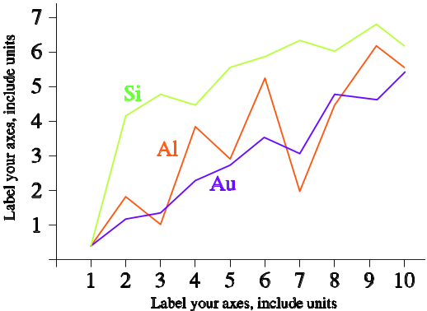
Fig. 1 A sample line graph using colors which contrast well both on screen and on a black-and-white hardcopy

Fig. 2 shows an example of a low-resolution image which would not be acceptable, whereas Fig. 3 shows an example of an image with adequate resolution. Check that the resolution is adequate to reveal the important detail in the figure.
Please check all figures in your paper both on screen and on a black-and-white hardcopy. When you check your paper on a black-and-white hardcopy, please ensure that:
- the colors used in each figure contrast well,
- the image used in each figure is clear,
- all text labels in each figure are legible.
- Figure Captions
Figures must be numbered using Arabic numerals. Figure captions must be in 8 pt Regular font. Captions of a single line (e.g. Fig. 2) must be centered whereas multi-line captions must be justified (e.g. Fig. 1). Captions with figure numbers must be placed after their associated figures, as shown in Fig. 1.

Fig. 2 Example of an unacceptable low-resolution image

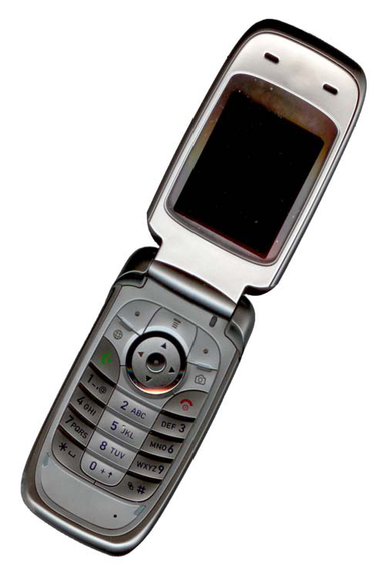
Fig. 3 Example of an image with acceptable resolution

- Table Captions
Tables must be numbered using uppercase Roman numerals. Table captions must be centred and in 8 pt Regular font with Small Caps. Every word in a table caption must be capitalized except for short minor words as listed in Section III-B. Captions with table numbers must be placed before their associated tables, as shown in Table 1.
- Page Numbers, Headers and Footers
Page numbers, headers and footers must not be used.
- Links and Bookmarks
All hypertext links and section bookmarks will be removed from papers during the processing of papers for publication. If you need to refer to an Internet email address or URL in your paper, you must type out the address or URL fully in Regular font.
- References
The heading of the References section must not be numbered. All reference items must be in 8 pt font. Please use Regular and Italic styles to distinguish different fields as shown in the References section. Number the reference items consecutively in square brackets (e.g. [1]).
When referring to a reference item, please simply use the reference number, as in [2]. Do not use “Ref. [3]” or “Reference [3]” except at the beginning of a sentence, e.g. “Reference [3] shows …”. Multiple references are each numbered with separate brackets (e.g. [2], [3], [4]–[6]).
Examples of reference items of different categories shown in the References section include:
- example of a book in [1]
- example of a book in a series in [2]
- example of a journal article in [3]
- example of a conference paper in [4]
- example of a patent in [5]
- example of a website in [6]
- example of a web page in [7]
- example of a databook as a manual in [8]
- example of a datasheet in [9]
- example of a master’s thesis in [10]
- example of a technical report in [11]
- example of a standard in [12]
- Conclusions
The version of this template is V2. Most of the formatting instructions in this document have been compiled by Causal Productions from the IEEE LaTeX style files. Causal Productions offers both A4 templates and US Letter templates for LaTeX and Microsoft Word. The LaTeX templates depend on the official IEEEtran.cls and IEEEtran.bst files, whereas the Microsoft Word templates are self-contained. Causal Productions has used its best efforts to ensure that the templates have the same appearance.
Causal Productions permits the distribution and revision of these templates on the condition that Causal Productions is credited in the revised template as follows: “original version of this template was provided by courtesy of Causal Productions (www.causalproductions.com)”.
Acknowledgment
The heading of the Acknowledgment section and the References section must not be numbered.
Causal Productions wishes to acknowledge Michael Shell and other contributors for developing and maintaining the IEEE LaTeX style files which have been used in the preparation of this template. To see the list of contributors, please refer to the top of file IEEETran.cls in the IEEE LaTeX distribution.
References
- S. M. Metev and V. P. Veiko, Laser Assisted Microtechnology, 2nd ed., R. M. Osgood, Jr., Ed. Berlin, Germany: Springer-Verlag, 1998.
- J. Breckling, Ed., The Analysis of Directional Time Series: Applications to Wind Speed and Direction, ser. Lecture Notes in Statistics. Berlin, Germany: Springer, 1989, vol. 61.
- S. Zhang, C. Zhu, J. K. O. Sin, and P. K. T. Mok, “A novel ultrathin elevated channel low-temperature poly-Si TFT,” IEEE Electron Device Lett., vol. 20, pp. 569–571, Nov. 1999.
- M. Wegmuller, J. P. von der Weid, P. Oberson, and N. Gisin, “High resolution fiber distributed measurements with coherent OFDR,” in Proc. ECOC’00, 2000, paper 11.3.4, p. 109.
- R. E. Sorace, V. S. Reinhardt, and S. A. Vaughn, “High-speed digital-to-RF converter,” U.S. Patent 5 668 842, Sept. 16, 1997.
- (2002) The IEEE website. [Online]. Available: http://www.ieee.org/
- M. Shell. (2002) IEEEtran homepage on CTAN. [Online]. Available: http://www.ctan.org/tex-archive/macros/latex/contrib/supported/IEEEtran/
- FLEXChip Signal Processor (MC68175/D), Motorola, 1996.
- “PDCA12-70 data sheet,” Opto Speed SA, Mezzovico, Switzerland.
- A. Karnik, “Performance of TCP congestion control with rate feedback: TCP/ABR and rate adaptive TCP/IP,” M. Eng. thesis, Indian Institute of Science, Bangalore, India, Jan. 1999.
- J. Padhye, V. Firoiu, and D. Towsley, “A stochastic model of TCP Reno congestion avoidance and control,” Univ. of Massachusetts, Amherst, MA, CMPSCI Tech. Rep. 99-02, 1999.
- Wireless LAN Medium Access Control (MAC) and Physical Layer (PHY) Specification, IEEE Std. 802.11, 1997.

